

qualireport

TutorialsNinja Web Application



October 3, 2023

SOLAYTIC

Hitech City, Pune

Table of Contents

Quality Status 2

Test Environments Covered 2

List of Existing Defects 2

# Quality Status

The quality of the TutorialsNinja Application Version 13.56 is better than the previous versions. In this version, the important issues still exits and hence we ‘**Not Recommend this version for Release**’.

# Test Environments Covered

We have tested TutorialsNinja Web Application Version 13.56 in all the below different Test Environments:

* Windows 10 – Chrome, Firefox, IE 11 and Edge
* Mac OS – Safari Browser
* Linux Ubuntu OS – Firefox
* Android Mobile OS – Chrome
* iPhone Mobile OS – Safari

# Defects by Functional Area

The below is the count of existing defects by Functional Are

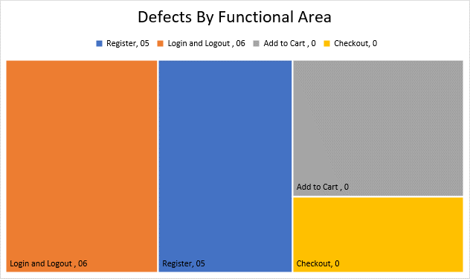

# List of Existing Defects

The below are the list of existing defects which are still existing in the TutorialsNinja Web Application Version 13.56:

|  |  |  |
| --- | --- | --- |
| **Defect#** | **Description** | **Severity** |
| TU1-I2 | Thank you for registering' email is not received to the registered email address after registering an account | Minor |
| TU1-I4 | 'Privacy Policy' Checkbox field in 'Register Account' page is not marked with red colour * symbol | Minor |
| TU1-I5 | 'Telephone' field in 'Register Account' page is accepting the spaces and not showing warning message | Minor |
| TU1-I6 | 'Password' and 'Password Confirm' fields in 'Register Account' page are accepting simple passwords | Major |
| TU1-I7 | Leading and Trailing spaces are accepted by the text fields in the 'Register Account' page | Minor |
| TU1-I8 | User is getting logged out on clicking Browser back button | Critical |
| TU1-I9 | User is getting logged in automatically on browsing back immediately after logout | Major |
| TU1-I10 | User is getting logged in automatically on browsing back immediately after logout | Major |
| TU1-I11 | User is not automatically getting logged out of the Application after 30 minutes of inactivity | Minor |
| TU1-I12 | User is not getting logged out in one browser, when logged out in another browser | Minor |